Thanksgiving is a time for friends, family and holiday feasts—but also a time for possible distress for our animal companions. Pets won’t be so thankful if they munch on undercooked turkey or a pet-unfriendly floral arrangement, or if they stumble upon an unattended alcoholic drink.

Check out the following tips from our friends at the ASPCA for a fulfilling Thanksgiving that your pets can enjoy, too:

- Talkin’ Turkey: If you decide to feed your pet a small bite of turkey, make sure it’s boneless and well-cooked. Don't offer her raw or undercooked turkey, which may contain salmonella bacteria.

- Do not give your pet the left over carcass–the bones can be problematic for the digestive tract.

- No Bread Dough: Don't spoil your pet’s holiday by giving him access to raw yeast bread dough.
- When a dog or cat ingests raw bread dough, the yeast continues to convert the sugars in the dough to carbon dioxide gas and alcohol. This can result in bloated drunken pets, which could become a life-threatening emergency, requiring hospitalization.

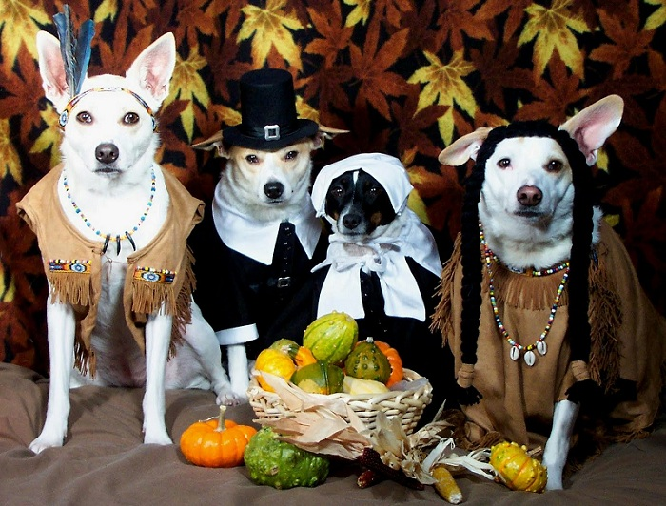
- Don't Let Them Eat Cake: If you plan to bake Thanksgiving desserts, be sure your pets keep their noses out of the batter, especially if it includes raw eggs—they could contain salmonella bacteria that may lead to food poisoning.

- A Feast Fit for a King: While your family enjoys a special meal, give your cat and dog a small feast of their own. Offer them made-for-pets chew bones. Or stuff their usual dinner—perhaps with a few added tidbits of turkey, vegetables (try sweet potato or green beans) and dribbles of gravy—inside a food puzzle toy. They’ll be happily occupied for awhile, working hard to extract their dinner from the toy.

A few small boneless pieces of cooked turkey, a taste of mashed potato or even a lick of pumpkin pie shouldn’t pose a problem. However, don't allow your pets to overindulge, as they could wind up with a case of stomach upset, diarrhea or even worse—an inflammatory condition of the pancreas known as pancreatitis. In fact, it’s best keep pets on their regular diets during the holidays.

